Project 9
Due 4/29/2018 by 11:59 PM
No delay is accepted
Post your answer in the folder Project 9 on the blackboard.
If you have any question please email me at mbadii@pace.edu

This is your final project. As I mentioned in the syllabus the last project and any leftover project must be posted by the above due date (Due 4/29/2018, 11:59 P.M.). After the due date I do not accept any late or revised project.

You could upload your previous projects twice. But you can upload this project one time only.

Test the programs in the document: Programs to Test on AWS. These programs are from the lectures. Make a report to explain how you made an account, how you stored a text file, how you tested the Java Server Program, and how you tested the C programs in AWS.
Write your report under the word: Answer. Write your user name/password on AWS. I then login to your account to test and check.

Answer.

I created an account on AWS

Username: at76348n@pace.edu
Password: ParallelProgramming610

First I followed the instructions provided in order to setup an EC2 instance for an Ubuntu server. I downloaded the Key Pair that was provided. This will allow me to log into the instance I created. The way I used to gain access to the instance was through my Ubuntu virtual server. Using the .pem key pair file, I had to secure it with the command chmod 400 <key_pair>.pem.

After that I used the command - ssh -i "AdjitKP1.pem" ubuntu@ec2-54-173-40-104.compute-1.amazonaws.com

Additionally, I had to use PuttyGen to create a .ppk file that I could use with WinSCP to transfer files to my instance. I created all of my files on my local computer then used WinSCP to transfer the files into a folder called testApps on the server. I created separate files for each of the test programs – a1.c, a2.c, a3.c, a4.c, then compiled and ran them all to test.

In order to be able to compile all of the programs I needed to install certain packages on the server. First to compile the Java program I needed to run the command – sudo apt install default-jdk – Then I had to install gcc with the command – sudo apt install gcc
Then I had to install mpicc to run mpi with the command – sudo apt install libmpich-dev

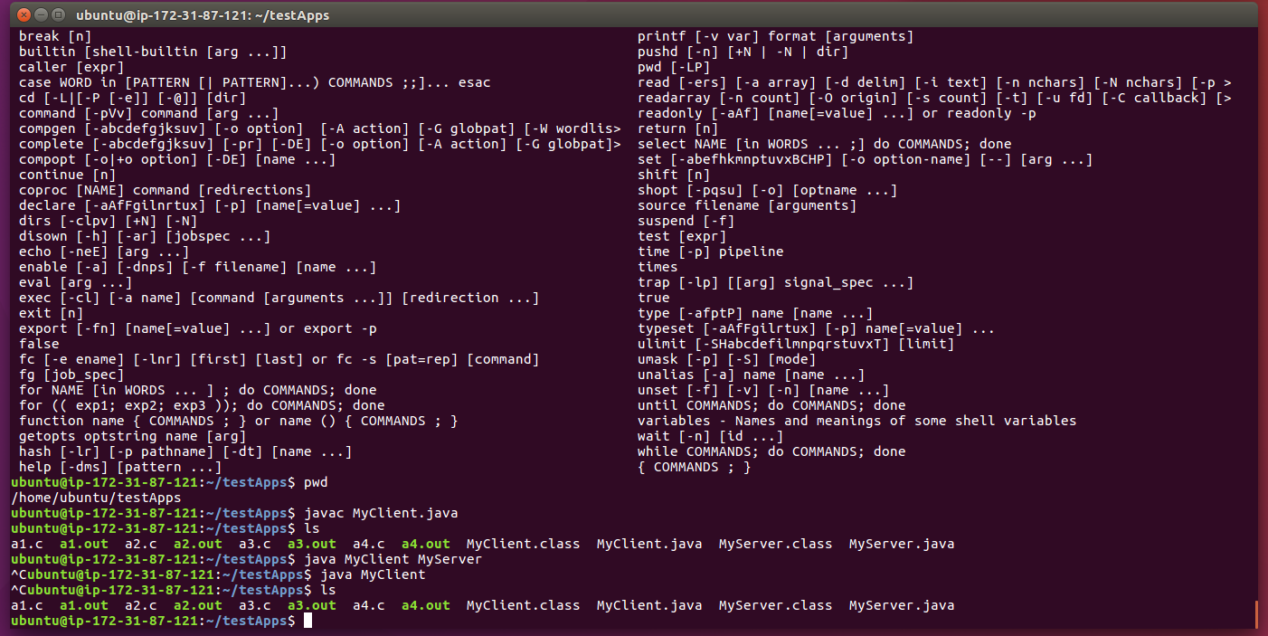
I was able to run all of the C programs well, however, I was unable to get the Java server client talking with each other.

